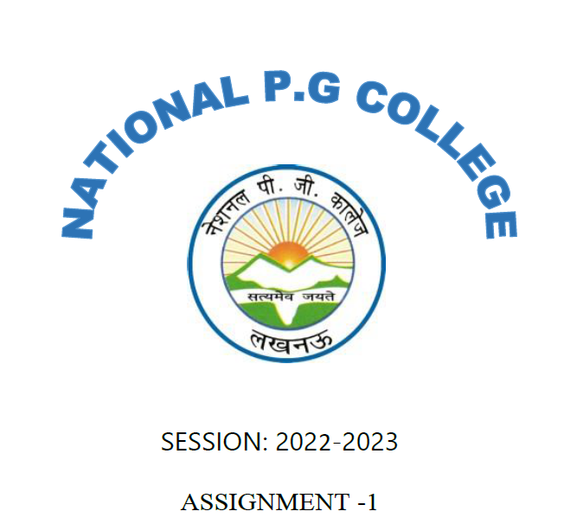

**PRACTICAL ASSIGNMENT**

2024-2025

SUBMITTED TO: SUBMITTED BY:

Mr. Amit Srivastava Sir Srajan Saxena

722035